13. ReactJS-HOL:
Create a react app with the name “bloggerapp” & open it in the vs code.
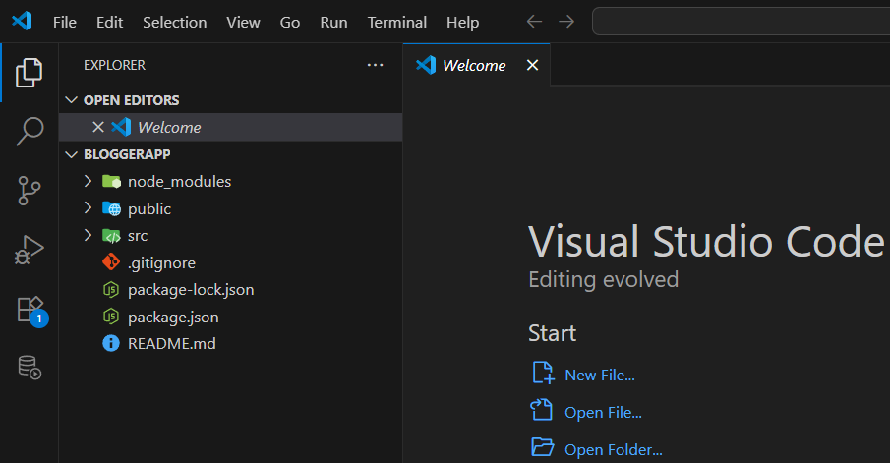
We achieve conditional rendering in different ways like:
- Using if…else statements
- Using logical &&(and) operator
- Using Element variable
- Using Ternary operator
- Using switch statement
Since we need render 3 components it is not possible to achieve it with the ternary operator instead of it we switch statement.
First let us create all the 3 components with the names CourseDetails, BookDetails, BlogDetails.
CourseDetails component:
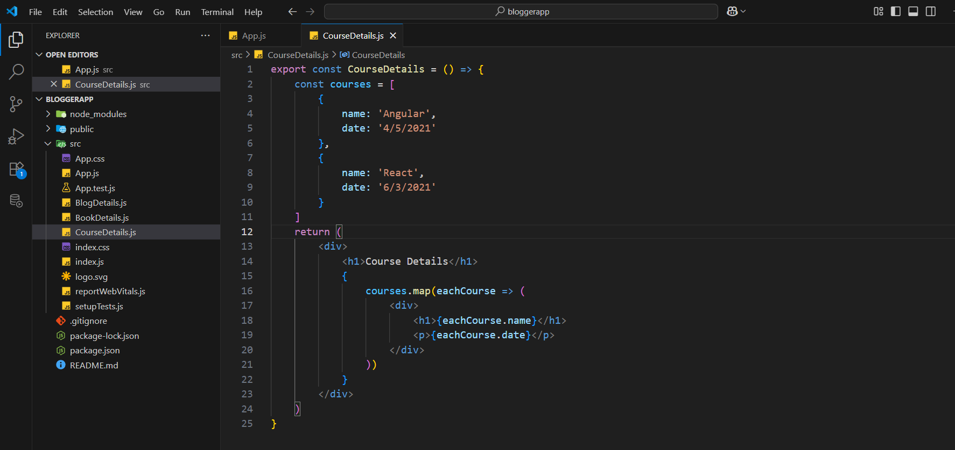
BookDetails component:
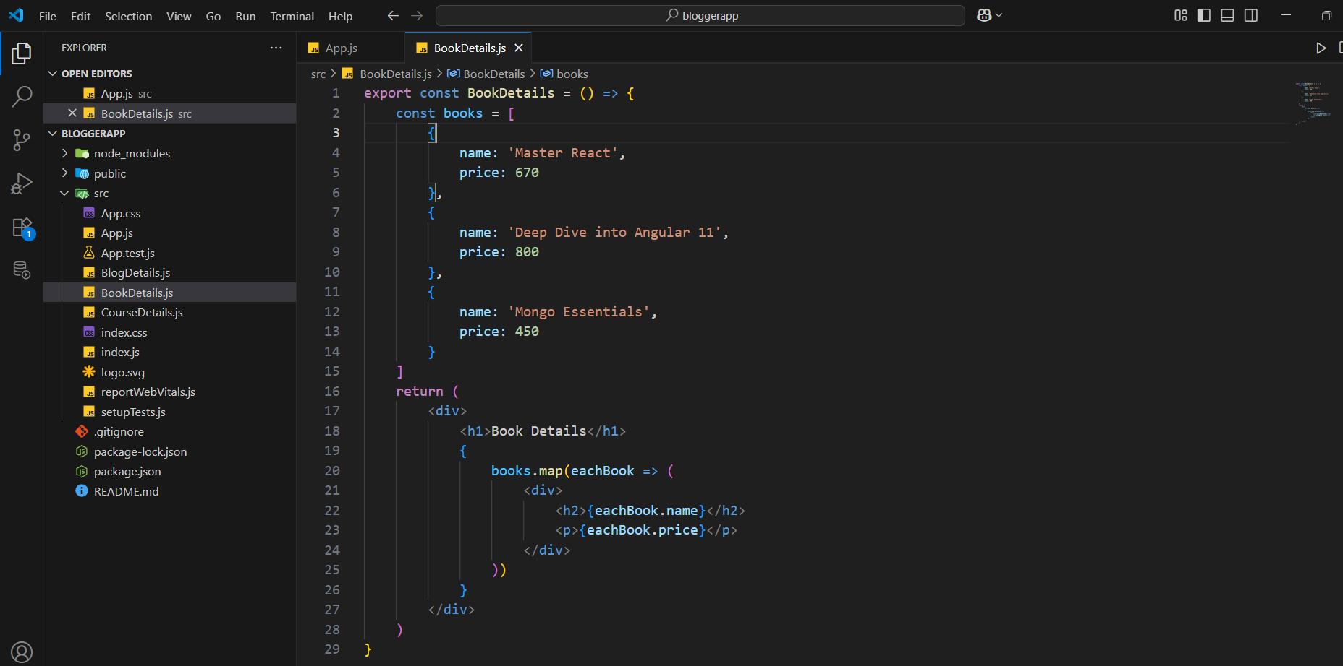
BlogDetails component:
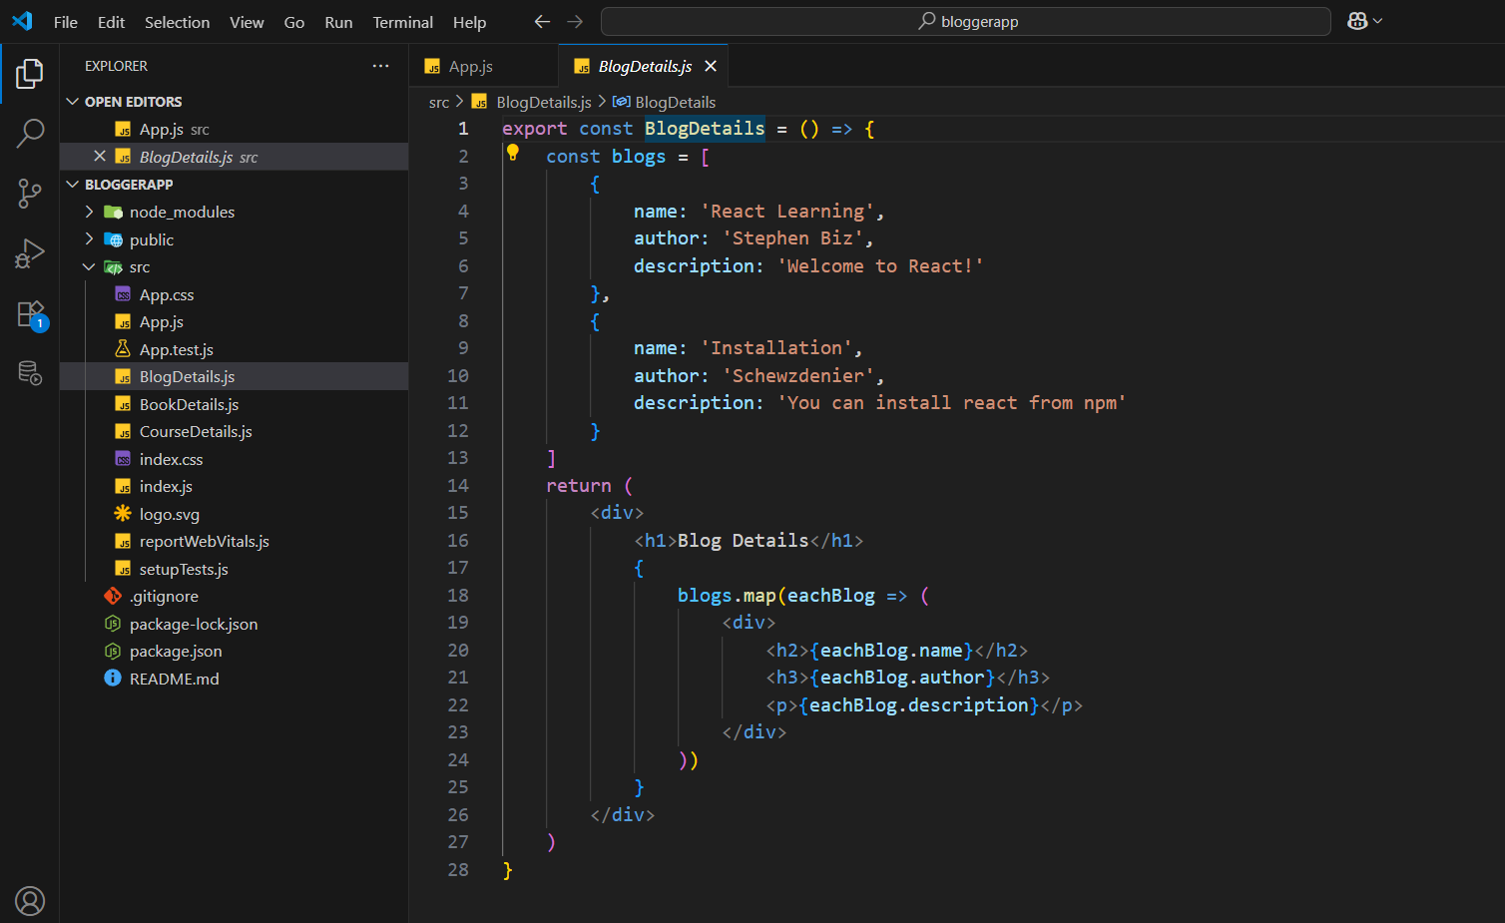
App component:
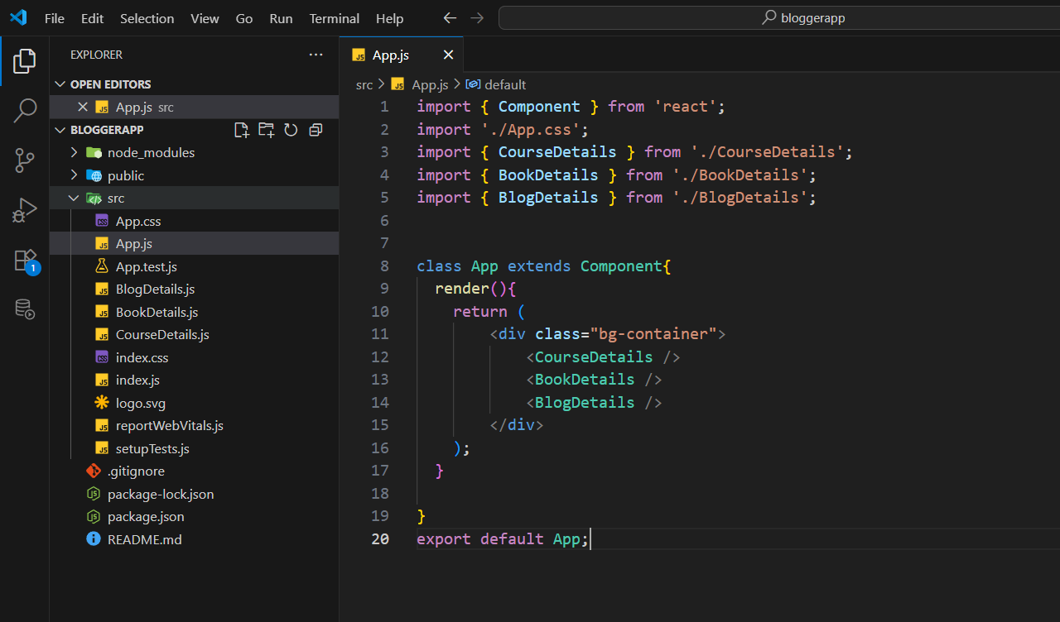
We have rendered all the 3 components
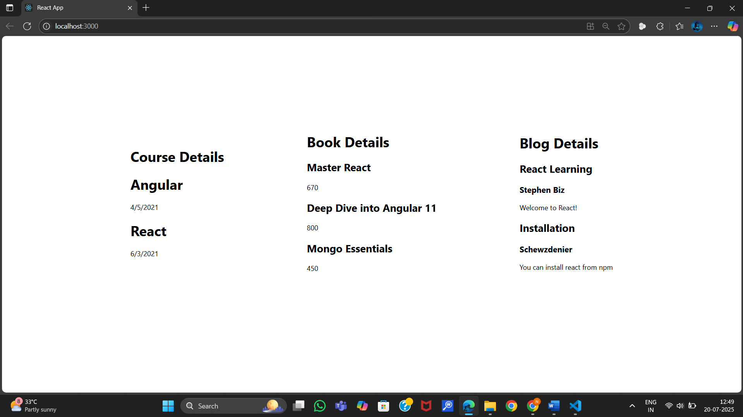
Now lets us apply conditional rendering.
To change achieve this lets us add 3 buttons showCourseDetails, showBookDetails, showBlogDetails buttons to render only one component based on the action using conditional rendering.

App component:
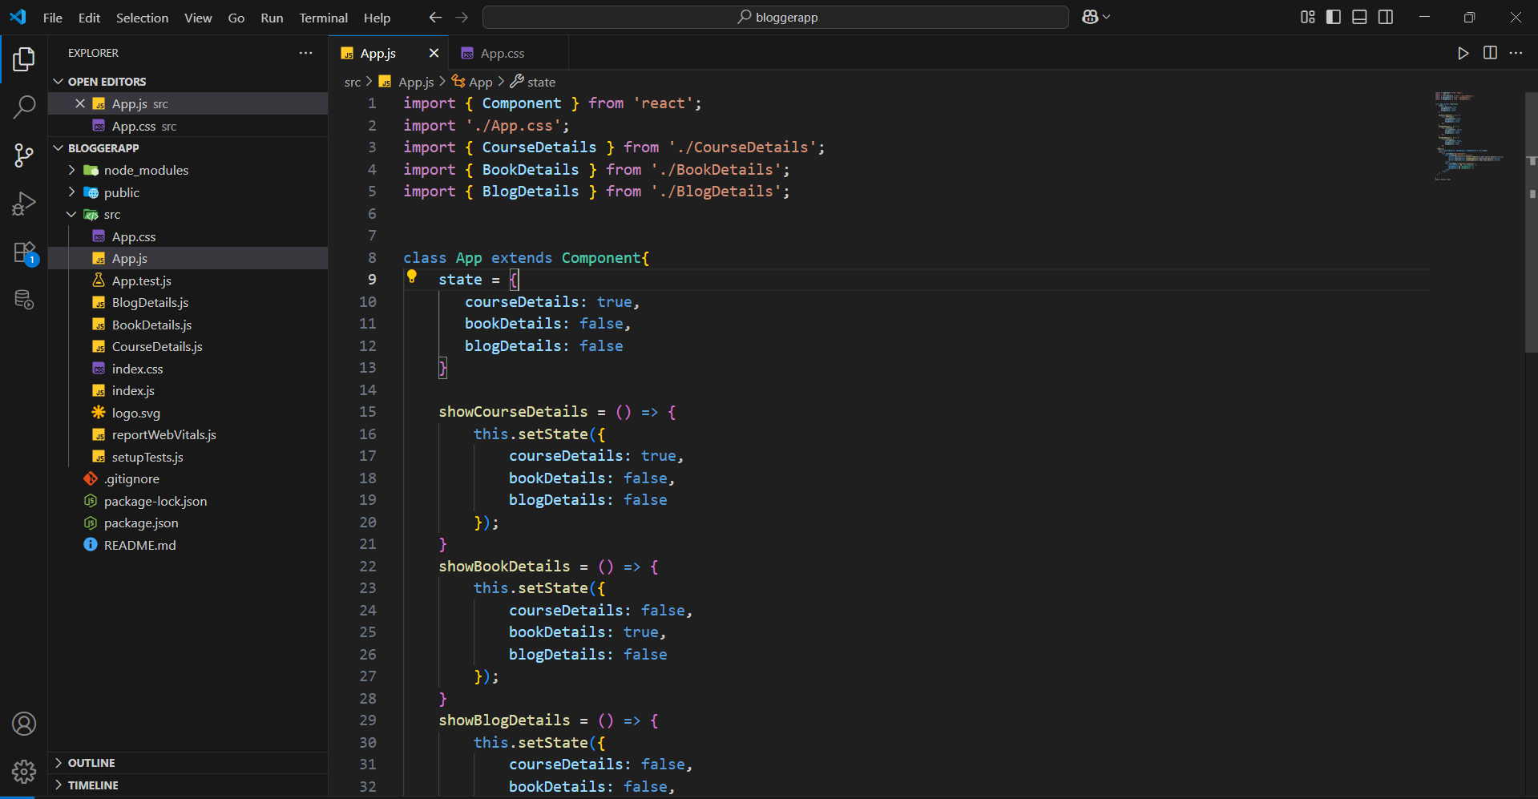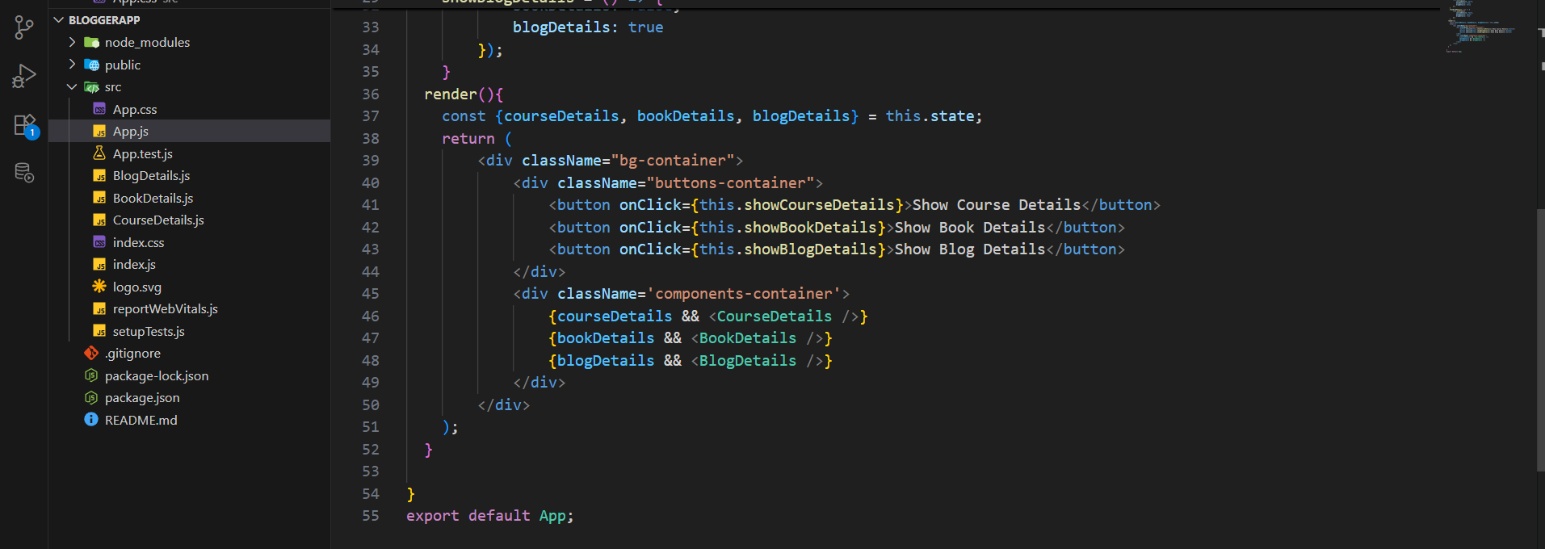
Here we used rendering using the logical operator &&(and).

App component:
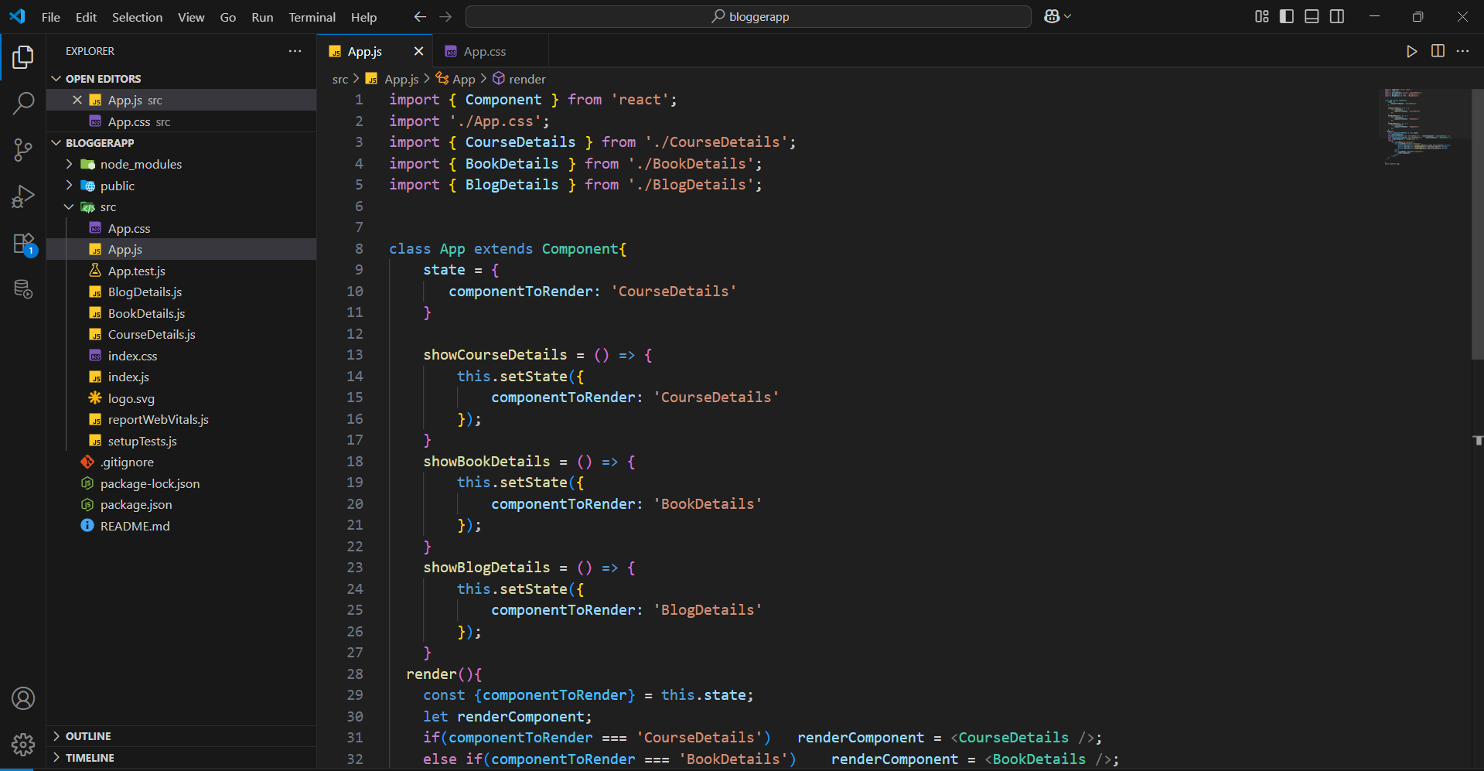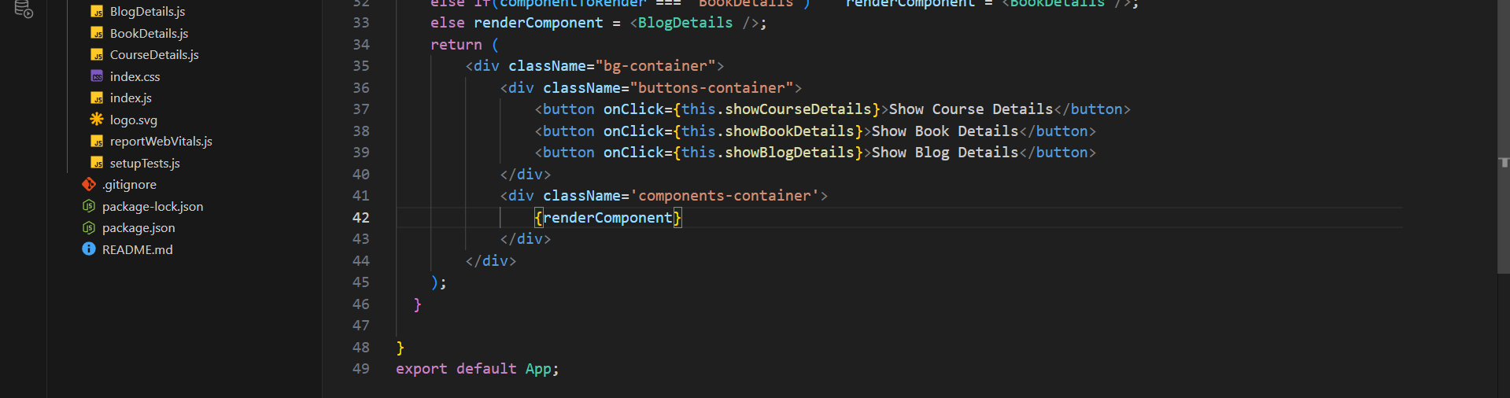
Here we rendered the components using Element variable.

App Component:
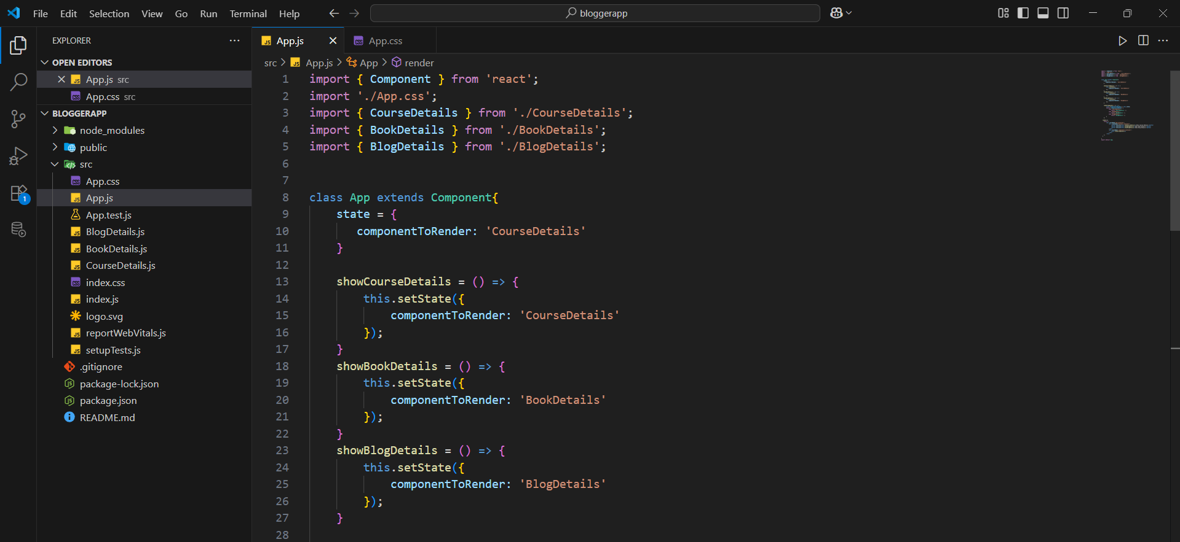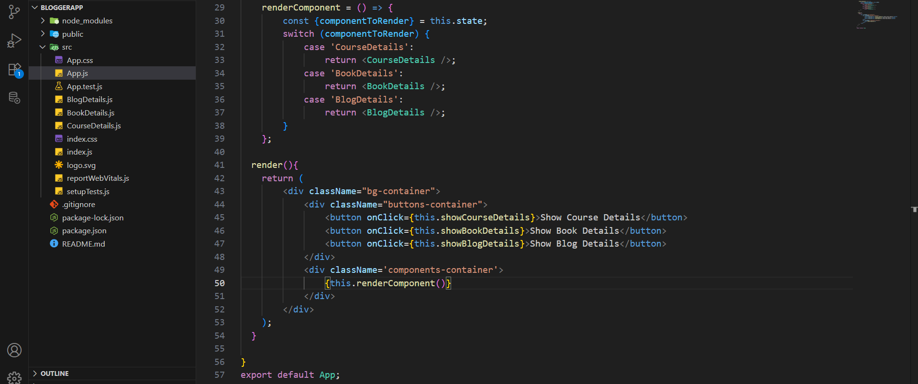
Here we have rendered the component using switch statement.

App component:
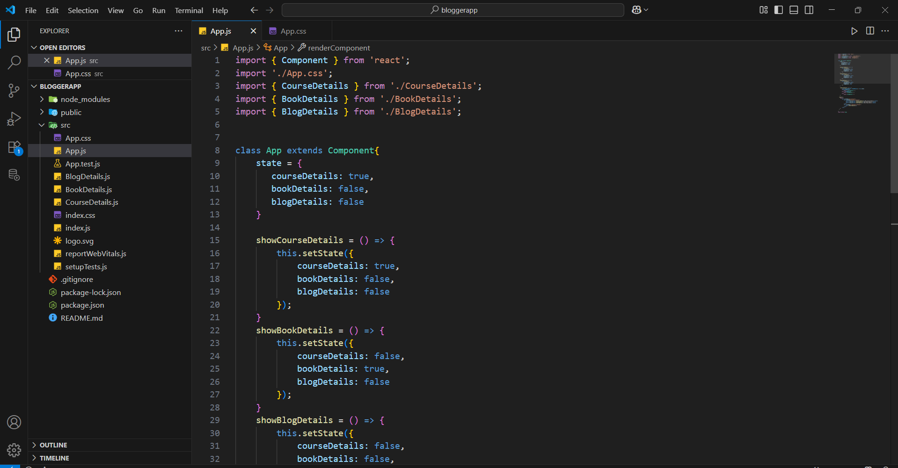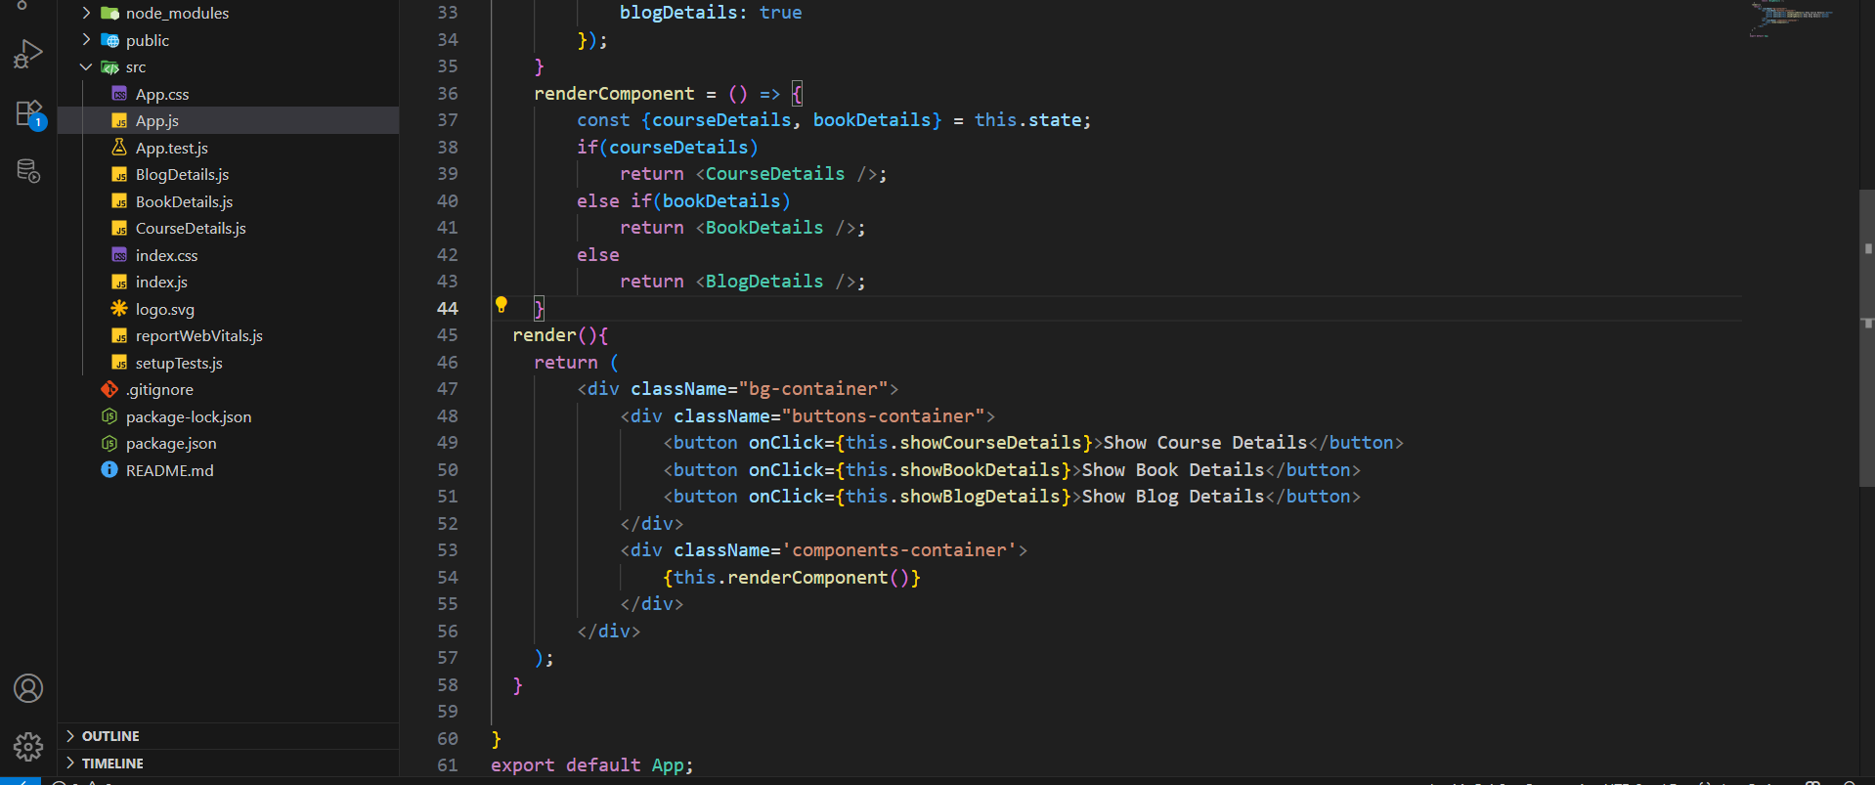
here we rendered the components using if…else statements.

Output:
The output of all types of rendering is same as shown below.

